Consulting case - inspired from Kopp et al. (2024)

A collaborator asks for your advise on what analysis to pre-register for her weight-loss trial.

She articulates the research question as ’compare the effect of a conventional vs. carbohydrate-reduced high-protein diet on weight loss among individuals with type 2 diabetes and high BMI’.

She also tells you that:
- the participants will receive meal kits corresponding to food covering 2/3 of the participant estimated energy requirements during 52 weeks.
- patient will undergo regular study visits:
week 0 (baseline): height and weight are measured
week 17 (follow-up 1): weight is measured and adherence to diet is monitored.
week 35 (follow-up 2): weight is measured and adherence to diet is monitored.
week 52 (follow-up 3): weight is measured and adherence to diet is monitored.
week 68 (follow-up 4): weight is measured and adherence to diet is monitored.
- the long-term effects are of most interest so 68 weeks should drive the group comparison.
- BMI = weight/height
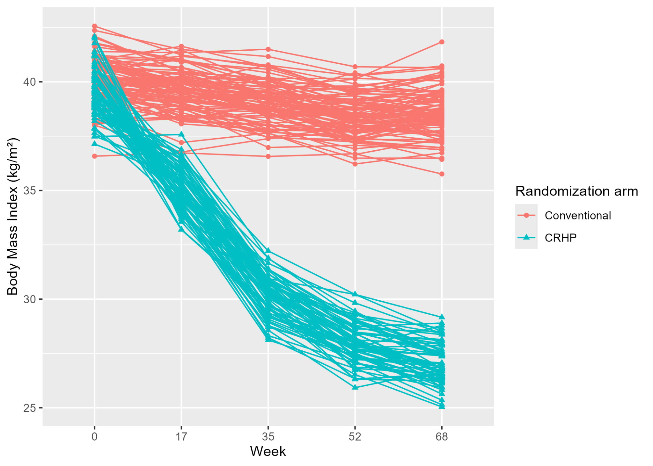
1.a If the study went completely as planned, how would you compare the two diets?

b. Rephrase in term of estimand:
- treatment
- population
- variable of interest
- summary measure
(perfect adherence, no missing data, no intercurrent event in this idealised study)
Figure 1: simulated data where each line represents a study participant.

2. One complication that the collaborator anticipates is that some study participants, tired or disappointed by the study, may stop adhering to the carbohydrate-reduced high-protein diet, stop coming to the study visits, and resume their former diet (high fat and sugar diet). These study participants will be referred to as ‘drop-out’.

She nevertheless expects to convince some of these study participants (say 50%) to only come back at the last visit and just measure their weight. They will be referred to as ‘retrieved-drop out’. See figure below for an illustration:

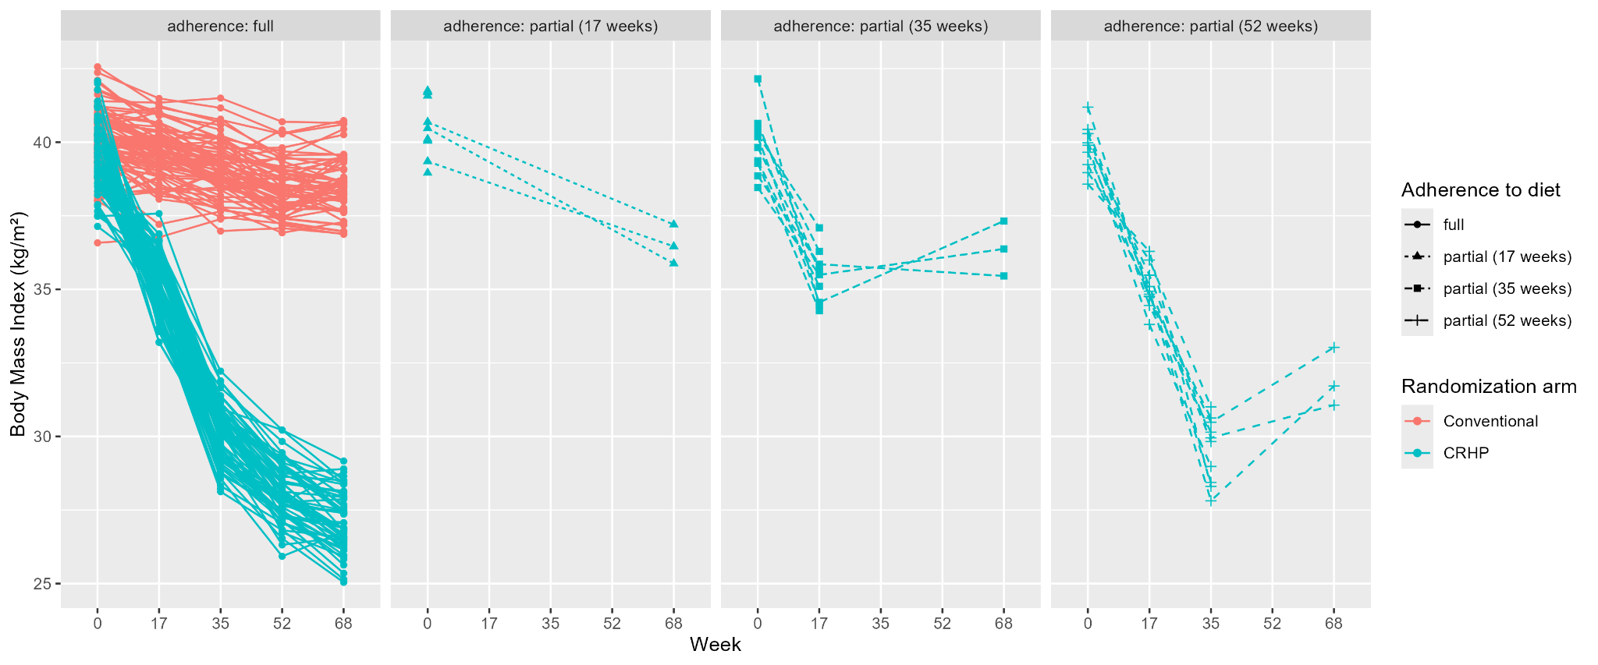
Figure 2: study participants in the 3 right-most panels with missing week 68 measurements are referred to as ‘drop-out’ while those with week 68 measurements as ‘retrieved drop-out’

How do you suggest dealing with this intercurrent event ‘lack of adherence’?

3. What other complications/intercurrent events could be considered?

Reference
Kopp, L. H., et al. (2024). Effects of a carbohydrate-reduced high-protein diet delivered with meal kits to danish people with type 2 diabetes: protocol for a 12-month randomised controlled trial. BMJ open, 14(8):e084686. DOI: 10.1136/bmjopen-2024-084686.

